Doc Writer: Capgemini (KDAS) Doc Date: May 18, 2015.
Application or System Name
Contract Account Sales MFA – BI Report
Contract Acct Power Factor – BI Report
General Overview
Business Requirements:
The changes in R4B impacts two BI reports and backend data providers:
- Contract Account Sales – MFA is based on the Billing Analysis (ZEREV_M01) Multiprovider
- Contract Acct PF is based on the Billing & Operand Infoset (ZBLO_IS01)

The requirements are:
- SAP ECC Data source: There are two new installation facts – “Power Factor - PWERFTCALC” and “Max Demand - KW_MX_DEMR” need to be included in the SAP BW data providers. There is an active standard extractor that pulls installation facts data from SAP ECC to the BW system - Installation Facts (Technical Name 0UC_INSTFACTS). This data source is extracting the two new operands data, so no enhancement is required.
- SAP BW Data Target: The installation facts data is stored in the Data Store Object (DSO) in BW - 0UC_INSTFACTS (Technical Name 0UCS_DS06). This DSO is not a key figure based DSO; i.e. Power Factor and Max Demand Operand values will not be added as two new key figures. The requirement is to provision these two Operands’ data into this standard DSO. No enhancement is required for this DSO.
- SAP BW Reporting Multiprovider: The two reports are based on the two Multiproviders (Multiproviders are used for creating BI reports and mapping from different data targets are done) - ZEREV_M01, ZBLO_IS01. The requirement is to provision new Operand’s data for the BI reports that are created on the top of these Multiproviders.
- SAP BI Reports: The reports mentioned above are existing reports and they need to be changed to accommodate the new Operand’s data into them. It is important to note that these reports are created by the users in the production environment (i.e. BWP system). So, two new reports are created to replace/add to the existing production reports.
- Security requirements: This includes verifying that existing report role – ZMBIW_CCS_FICA_______ANALYTICS allow the business users to access new Operand’s data on the BI reports.
- Batch Job requirements: No change required for the existing process chain(s) or Redwood Job(s).

Technical Design:
BI Report: Contract Acct PowerFactor ZBI_ZBLO_IS01_PWRFCTR
- This report is based on the Multiprovider ZBLO_IS01
- Two new key figure columns are added to the existing report - Max Demand KW_MX_DEMR and Calculated Power Factor-Ifact PWERFTCALC
System Diagram
- Selection Screen
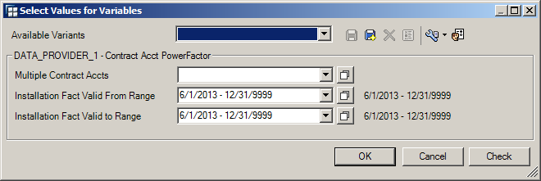
Please note that both variables for valid to and valid from should be same.

Query definition – Filter
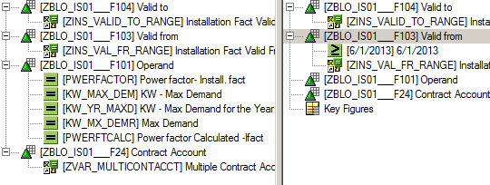
Query definition – Rows/Columns
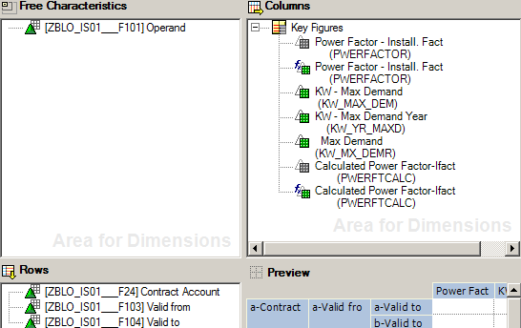

Please note that the definition of the columns and rows are copied from the production report other than the last two columns.

BI Report: Contract Account Sales MFA
There are two Business Explorer queries created for this report and the report is available in the form of a workbook.
Queries are:
Query # 1: Contract Account Sales ZBI_ZEREV_M01_MFA1106
Query # 2: Contract Account Sales IFact ZBI_ZEREV_M01_MFA1106_IFACT
- These two queries are based on the Multiprovider ZEREV_M01
- Two queries are combined in the Contract Account Sales MFA workbook
System Diagram
- Selection Screen
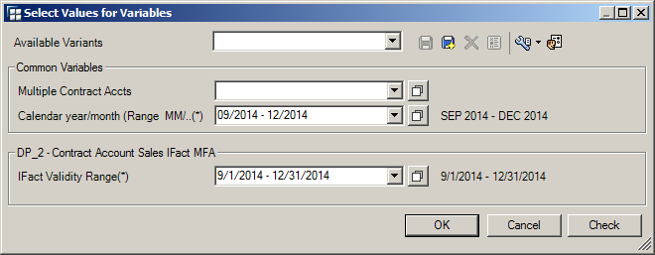
Please note that both variables for Calendar year/month and IFact Validity Range should reflect the same date range.

Query definition – Filter of Query # 1
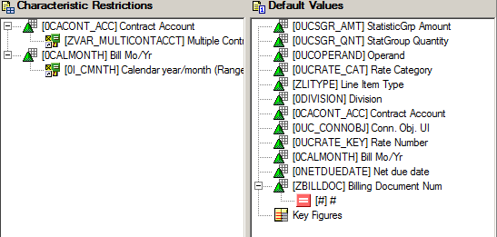
Query definition – Rows/Columns of Query # 1
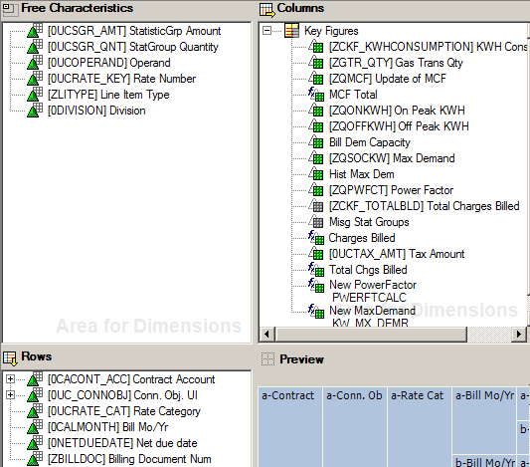

Query definition – Filter of Query # 2
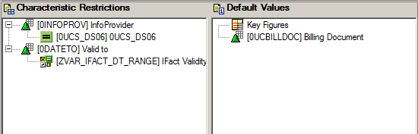
Query definition – Rows/Columns of Query # 2
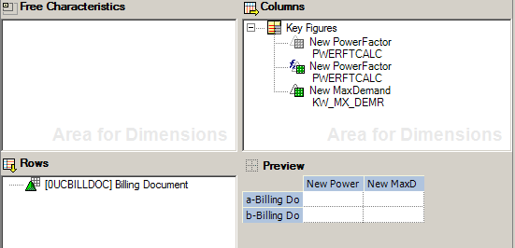

Workbook - Contract Account Sales MFA
This workbook keeps the query number one as is on Tab # 1 and query number two is on the Tab # 2. The first query has a field billing document which is also available on the second query. Two new columns are added to the first tab for Power factor and Max Demand and they are also available on the second tab.
A “callback” macro is created and added to the workbook. This macro is called at the end of execution of the BEx queries. This macro pulls the Power Factor and Max Demand values to the first tab from the second tab by looking up based on the Billing Document field.

Technical Parts Inventory

-------Name------- | ----Description---- | -----Location----- | ----Environment---
ZBI_ZBLO_IS01_PWRFCTR | BEx Query |  | B4D
ZBI_ZEREV_M01_MFA1106 | BEx Query Contract Account Sales |  | B4D
ZBI_ZEREV_M01_MFA1106_IFACT | BEx Query Contract Account Sales IFact |  | B4D
Contract Account Sales MFA | Workbook |  | B4D

Dependent Parts Inventory
-------Name------- | ----Description--- | -----Location----- | ----Environment---

Security Roles and AD Group Needed to Run App

-------Name------- | ----Description---- | -----Location----- | ----Environment---
ZMBIW_CCS_FICA_______ANALYTICS | Security Role |  | B4D

